Name:Lokare Mahir Abdul Majeed
Roll No:23AI34
Batch:02

Experiment No: 03

AIM: To study and implementation of Linear Regression algorithm.

RESOURCE REQUIRED:
Google repository, Dataset, Jupyter Notebook

THEORY:
Linear regression is a type of supervised machine-learning algorithm that learns from the labelled datasets and maps the data points with most optimized linear functions which can be used for prediction on new datasets. It assumes that there is a linear relationship between the input and output, meaning the output changes at a constant rate as the input changes. This relationship is represented by a straight line
The linear regression model provides a sloped straight line representing the relationship between the variables. Consider the below image :
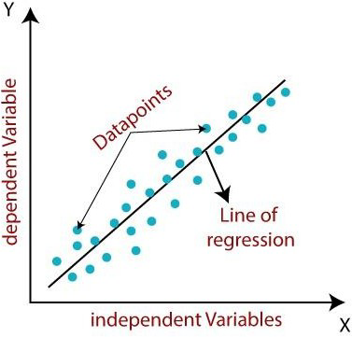
Fig. 3.1 Relationship between the variables

Mathematically, we can represent a linear regression as :
y= a0+a1x+ ε Here, y = Dependent Variable (Target Variable) x = Independent Variable (predictor Variable) a0= intercept of the line (Gives an additional degree of freedom) a1 = Linear regression coefficient (scale factor to each input value).
ε = random error
The values for x and y variables are training datasets for Linear Regression model representation.
Types of Linear Regression -
Linear regression can be further divided into two types of the algorithms :
- Simple Linear Regression :
If a single independent variable is used to predict the value of a numerical dependent variable, then such a Linear Regression algorithm is called Simple Linear Regression.
- Multiple Linear regression :
If more than one independent variable is used to predict the value of a numerical dependent variable, then such a Linear Regression algorithm is called Multiple Linear Regression.
Linear Regression Line -
A linear line showing the relationship between the dependent and independent variables is called a regression line. A regression line can show two types of relationship :
- Positive Linear Relationship :
If the dependent variable increases on the Y-axis and independent variable increases on Xaxis, then such a relationship is termed as a Positive linear relationship.
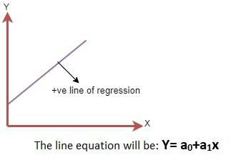
Fig. 3.2 Positive Linear Relationship

- Negative Linear Relationship :
If the dependent variable decreases on the Y-axis and independent variable increases on the X- axis, then such a relationship is called a negative linear relationship.
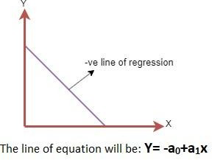
Fig. 3.3 Negative Linear Relationship
Evaluation Metrics for Linear Regression
A variety of evaluation measures can be used to determine the strength of any linear regression model. These assessment metrics often give an indication of how well the model is producing the observed outputs.
The most common measurements are:

Mean Square Error (MSE)
Mean Squared Error (MSE) is an evaluation metric that calculates the average of the squared differences between the actual and predicted values for all the data points. The difference is squared to ensure that negative and positive differences don't cancel each other out.
MSE=1n∑i=1n(yi−yi^)2MSE=n1∑i=1n(yi−yi)2
Here,
  - nn is the number of data points.
  - yiyi is the actual or observed value for the ithith data point.
  - yi^yi is the predicted value for the ithith data point.
MSE is a way to quantify the accuracy of a model's predictions. MSE is sensitive to outliers as large errors contribute significantly to the overall score.

Mean Absolute Error (MAE)
Mean Absolute Error is an evaluation metric used to calculate the accuracy of a regression model. MAE measures the average absolute difference between the predicted values and actual values. Mathematically MAE is expressed as:
MAE=1n∑i=1nYi−Yi^MAE=n1∑i=1nYi−Yi
Here,
  - n is the number of observations Yi represents the actual values.
  - Yi^Yi represents the predicted values
Lower MAE value indicates better model performance. It is not sensitive to the outliers as we consider absolute differences.

Root Mean Squared Error (RMSE)
The square root of the residuals' variance is the Root Mean Squared Error. It describes how well the observed data points match the expected values or the model's absolute fit to the data. In mathematical notation, it can be expressed as:
RMSE=RSSn=∑i=2n(yiactual−yipredicted)2nRMSE=nRSS=n∑i=2n(y_{iactual}−y_{ipredicted})₂
Where:
  - nn : Number of observations
  - yiyi : Actual value
  - yi^yi^ : Predicted value
RMSE is in the same unit as the target variable and highlights larger errors more clearly.

Coefficient of Determination (R-squared)
R-Squared is a statistic that indicates how much variation the developed model can explain or capture. It is always in the range of 0 to 1. In general, the better the model matches the data, the greater the R-squared number.
In mathematical notation, it can be expressed as:
R2=1−(RSSTSS)R2=1−(TSSRSS)
 Residual sum of Squares(RSS): The sum of squares of the residual for each data point in the plot or data is known as the residual sum of squares or RSS. It is a measurement of the difference between the output that was observed and what was anticipated.
RSS=∑i=1n(yi−b0−b1xi)2RSS=∑i=1n(yi−b0−b1xi)2
 Total Sum of Squares (TSS): The sum of the data points' errors from the answer variable's mean is known as the total sum of squares or TSS.
TSS=∑i=1n(y−yi‾)2TSS=∑i=1n(y−yi)2.
R squared metric is a measure of the proportion of variance in the dependent variable that is explained the independent variables in the model.

Adjusted R-Squared Error

Adjusted R2R2measures the proportion of variance in the dependent variable that is explained by independent variables in a regression model. Adjusted R-square accounts the number of predictors in the model and penalizes the model for including irrelevant predictors that don't contribute significantly to explain the variance in the dependent variables. Mathematically, adjusted R2R2is expressed as:
AdjustedR2=1−((1−R2).(n−1)n−k−1)AdjustedR2=1−(n−k−1(1−R₂).(n−1))
Here,
  - n is the number of observations
  - k is the number of predictors in the model
  - R² is coeeficient of determination
It penalizes the inclusion of unnecessary predictors, helping to prevent overfitting.

IMPLEMENTATION-
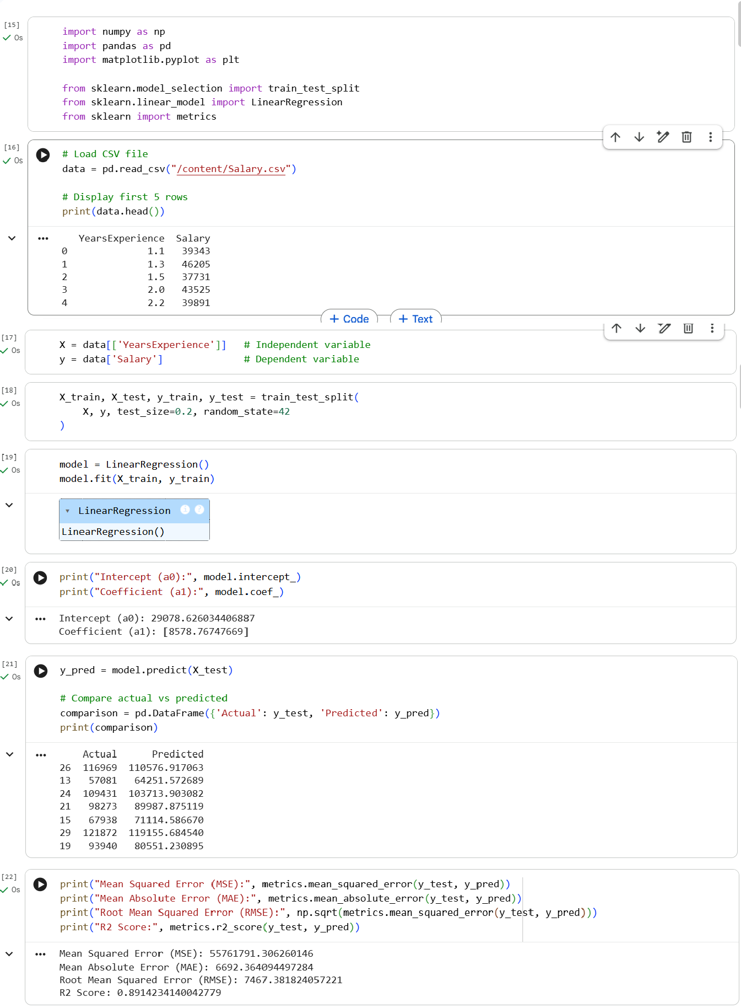
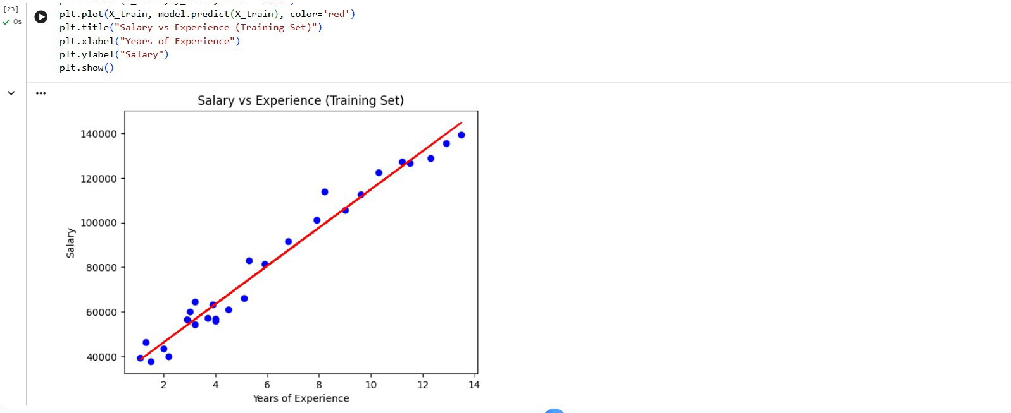

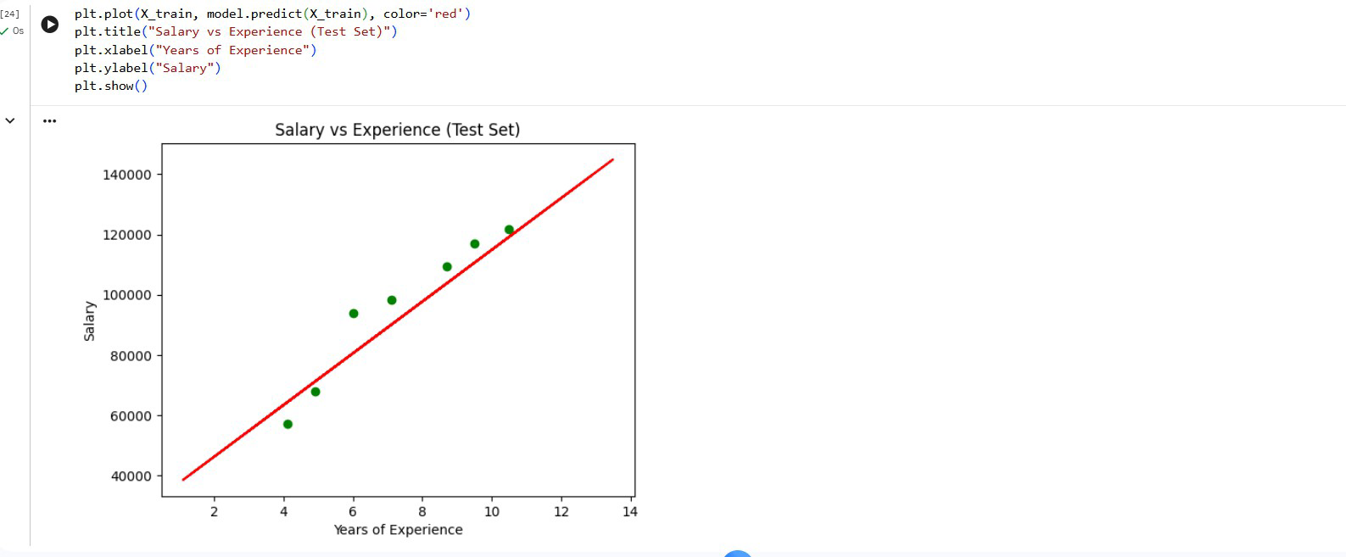

CONCLUSION –
Hence, the implementation of the linear regression algorithm was successfully performed on the dataset.

